**Supplementary Material**

## Figure S1:

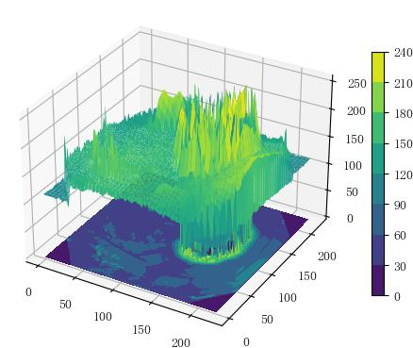



## **Figure S2:**

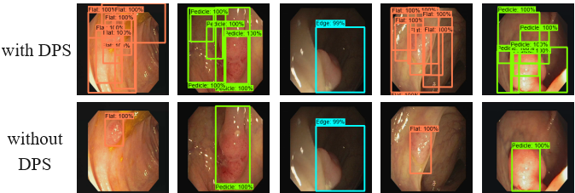

## **Figure S3:**

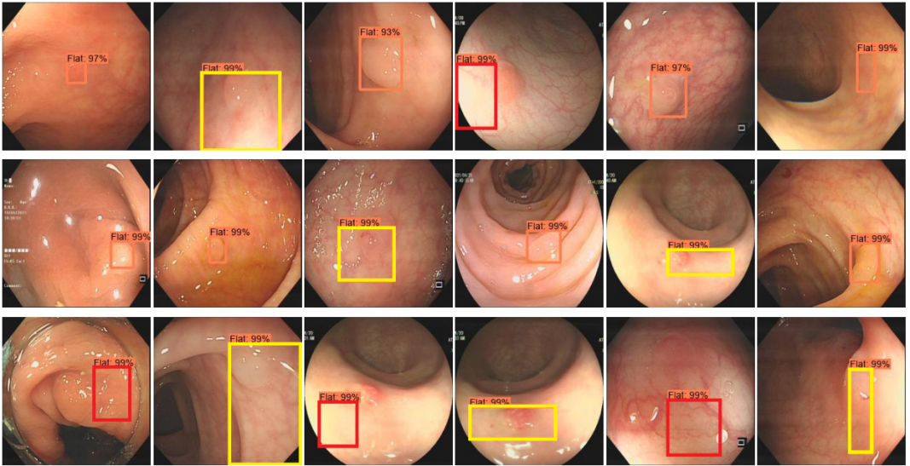

**Figure S4:**

|  |  |  |  |  |  |  |  |  |  |  |  |
| --- | --- | --- | --- | --- | --- | --- | --- | --- | --- | --- | --- |
| Methods | Supervision | | IoU@10 | | | IoU@30 | | | IoU@50 | | |
| Box | Class | Flat | Pedicle | Edge | Flat | Pedicle | Edge | Flat | Pedicle | Edge |
| Faster Rcnn | \Checkmark | \Checkmark | 0.00 | 77.50 | 46.15 | 0.00 | 77.50 | 46.15 | 0.00 | 76.20 | 46.15 |
| YOLOv3 | \Checkmark  ClinicDB | \Checkmark | 0.00 | 82.47 | 39.14 | 0.00 | 82.47 | 38.41 | 0.00 | 81.54 | 35.36 |
| DiffusionDet50 | \Checkmark | \Checkmark | 0.00 | 98.05 | 92.19 | 0.00 | 98.05 | 92.19 | 0.00 | 96.49 | 81.77 |
| DiffusionDet500 | \Checkmark | \Checkmark | 0.00 | 94.26 | 91.39 | 0.00 | 94.25 | 91.39 | 0.00 | 94.25 | 82.49 |
| WSDDN | -- | \Checkmark | 14.42 | 23.04 | 12.97 | 6.79 | 16.27 | 4.93 | 5.65 | 11.45 | 2.99 |
| OICR | -- | \Checkmark | 0.00 | 5.20 | 7.69 | 0.00 | 1.10 | 0.00 | 0.00 | 0.37 | 0.00 |
| WSOD2 | -- | \Checkmark | 26.97 | 51.57 | 34.04 | 4.72 | 38.63 | 34.04 | 2.97 | 38.63 | 34.04 |
| Grad-CAM | -- | \Checkmark | 32.06 | 74.49 | 19.78 | 3.74 | 34.99 | 0.00 | 0.12 | 11.70 | 0.00 |
| Grad-CAM++ | -- | \Checkmark | 26.70 | 73.17 | 45.74 | 3.94 | 30.47 | 4.62 | 0.05 | 10.92 | 2.37 |
| Ours | -- | \Checkmark | 77.01 | 68.10 | 76.92 | 63.96 | 49.48 | 51.05 | 55.92 | 15.21 | 30.91 |

## **Table S1:**

|  |  |  |  |  |  |  |  |  |  |  |  |
| --- | --- | --- | --- | --- | --- | --- | --- | --- | --- | --- | --- |
| Methods | Supervision | | IoU@10 | | | IoU@30 | | | IoU@50 | | |
| Box | Class | Flat | Pedicle | Edge | Flat | Pedicle | Edge | Flat | Pedicle | Edge |
| Faster Rcnn | \Checkmark | \Checkmark | 0.00 | 79.69 | 0.00 | 0.00 | 78.67 | 0.00 | 0.00 | 77.07 | 0.00 |
| YOLOv3 | \Checkmark | \Checkmark | 0.00 | 75.78 | 7.04 | 0.00 | 74.62 | 7.04 | 0.00 | 70.94 | 6.53 |
| DiffusionDet50 | \Checkmark | \Checkmark | 0.00 | 74.23 | 11.53 | 0.00 | 72.28 | 11.53 | 0.00 | 70.19 | 9.13 |
| DiffusionDet500 | \Checkmark | \Checkmark | 0.00 | 70.73 | 10.79 | 0.00 | 69.71 | 10.79 | 0.00 | 66.90 | 3.66 |
| WSDDN | -- | \Checkmark | 5.30 | 17.07 | 1.39 | 3.08 | 14.28 | 0.00 | 2.79 | 11.36 | 0.00 |
| OICR | -- | \Checkmark | 0.00 | 0.00 | 0.00 | 0.00 | 0.00 | 0.00 | 0.00 | 0.00 | 0.00 |
| WSOD2 | -- | \Checkmark | 0.00 | 4.80 | 0.00 | 0.00 | 4.61 | 0.00 | 0.00 | 4.55 | 0.00 |
| Grad-CAM | -- | \Checkmark | 0.71 | 36.53 | 0.00 | 0.08 | 10.81 | 0.00 | 0.00 | 2.25 | 0.00 |
| Grad-CAM++ | -- | \Checkmark | 0.36 | 36.85 | 0.00 | 0.10 | 10.90 | 0.00 | 0.01 | 2.78 | 0.00 |
| Ours | -- | \Checkmark | 4.57 | 60.69 | 12.50 | 1.00 | 41.27 | 12.50 | 0.50 | 19.23 | 12.50 |

## **Table S2:**

|  |  |  |  |  |  |  |  |  |  |  |  |
| --- | --- | --- | --- | --- | --- | --- | --- | --- | --- | --- | --- |
| Methods | Supervision | | IoU@10 | | | IoU@30 | | | IoU@50 | | |
| Box | Class | Flat | Pedicle | Edge | Flat | Pedicle | Edge | Flat | Pedicle | Edge |
| Faster Rcnn | \Checkmark | \Checkmark | 0.00 | 82.77 | 0.00 | 0.00 | 82.77 | 0.00 | 0.00 | 82.77 | 0.00 |
| YOLOv3 | \Checkmark | \Checkmark | 0.00 | 73.58 | 17.12 | 0.00 | 73.58 | 15.32 | 0.00 | 73.58 | 11.69 |
| DiffusionDet50 | \Checkmark | \Checkmark | 0.00 | 80.16 | 33.30 | 0.00 | 80.12 | 32.64 | 0.00 | 78.73 | 31.61 |
| DiffusionDet500 | \Checkmark | \Checkmark | 0.00 | 83.77 | 36.42 | 0.00 | 83.57 | 34.25 | 0.00 | 81.45 | 20.97 |
| WSDDN | -- | \Checkmark | 8.33 | 29.90 | 5.74 | 4.53 | 27.45 | 2.85 | 3.02 | 25.78 | 2.74 |
| OICR | -- | \Checkmark | 3.71 | 0.00 | 0.00 | 3.71 | 0.00 | 0.00 | 3.71 | 0.00 | 0.00 |
| WSOD2 | -- | \Checkmark | 0.00 | 3.03 | 0.00 | 0.00 | 3.03 | 0.00 | 0.00 | 3.03 | 0.00 |
| Grad-CAM | -- | \Checkmark | 0.00 | 68.60 | 2.78 | 0.00 | 39.87 | 0.00 | 0.00 | 31.34 | 0.00 |
| Grad-CAM++ | -- | \Checkmark | 0.00 | 62.03 | 2.92 | 0.00 | 39.44 | 0.00 | 0.00 | 29.89 | 0.00 |
| Ours | -- | \Checkmark | 35.81 | 68.65 | 31.67 | 20.83 | 68.65 | 18.89 | 15.49 | 55.58 | 18.89 |

**Table S3:**